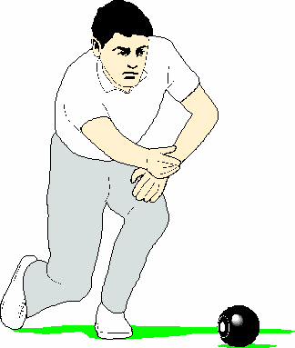
EWHURST SHORT MAT
BOWLS CLUB

Application for Membership

I Mr/Mrs/Miss/Ms……………………………………………….... wish to apply for
Delete as necessary First name Surname
membership of the Ewhurst Short Mat Bowls Club

Address: ...……………………..…………………….…….……….....................

................………….........Post Code ..................... Tel No.............................

E-mail address: ……………..………………….......……..…………...................
Please write clearly in lower case
How would you classify your bowling experience? None/Novice/Club/County

Are you now or have you previously been a member of a Bowls Club? Yes/No
If YES please provide details and dates……………………………………………..
Before you start playing we will arrange for you to have an evening at the club with a committee member to assess your ability. If you do need tuition on short mat bowling this can be arranged.

I understand that as a member of the Ewhurst Short Mat Bowls Club, I will be expected to assist with light duties from time to time that are essential for the enjoyment and efficient functioning of the Club and Bowling Centre.

Signature of Applicant…………………………………….. Date……………..…

Proposed by …………………………………… ………………………………
Member’s Name Signature
Seconded by …………………………………… ………………………………
Member’s Name Signature
Note: Those proposing/seconding candidates for membership should know the person and have been members for more than one season. Application must be confirmed by a committee member before submitting the form.

Please forward this application with your remittance as detailed below to:-
The Hon Sec., Pauline Shipway 27 Stanton Close, Cranleigh, Surrey, GU6 8UH

Joining Fee … … ... … … ( normally £25 but waived for applicants joining in 2021/22)
Annual Subscription (27/09/21 – 16 /04/22) … … … … … £40.00
Cheques to be made payable to ESMBC.

Membership is subject to the approval of the Committee and will be reviewed after six months.

Approved ……………………………….

